Orderbook Architecture Document
1. Introduction
1.1. Purpose
1.2. Definitions, Acronyms, and Abbreviations
2. Architectural Goals and Constraints
2.1. Setup
2.2. Reliability
2.3. Development tools
3. Use-Case View
3.1. Use case diagrams
3.2. Use case realisations
3.3. User specific use cases
3.3.1. View transaction history for symbol from navigation bar
3.3.2. View transaction history for symbol from home page
3.3.3. Show orderbook for a stock symbol from navigation bar
3.3.4. Show orderbook for a stock symbol from home page
3.3.5. Match existing order
3.3.6. Delete order
3.4. Automated use cases
3.4.1. Match orders
3.4.2. Create transaction
4. Activity Diagrams
4.1. Automatic Order Matching/Runtime processes
4.2. Adding an Order
5. Implementation View
6. Data View
6.1. ER diagram
6.2 MySQL implementation

Orderbook Requirements Document
- Introduction
1.1. Purpose This document provides a high level overview and explanation of an orderbook application. Contained within are sections that cover in detail the uses, implementation, and reasonings behind every component of the application.
1.2. Definitions, Acronyms, and Abbreviations
Term Definition
Order Book List of orders that show interest of buyers to sell or buy a financial instrument (stock)
Order A purchase or sale inquiry for a stock
Buy Order An inquiry to purchase a specific stock at a specific price
Sell Order An inquiry to sell a specific stock at a specific price

Order ID ID number for a given order
Size The volume of stock for a given order
Side Whether an order is a buy or sell order
Time (order) The time at which an order is placed
Active If the order listing is still available to execute
Offer Price The sale or buy price of a share of a stock order
Symbol Associated ticker symbol for a given stock
Transaction The fulfillment of a given buy order and sell order
Buy Order ID The Order ID associated with the buy order of a transaction
Sell Order ID The Order ID associated with the sell order of a transaction
Final Time The time at which a transaction is completed
Final Price The price at which the transaction was executed
Amount The volume of shares sold/bought in the transaction
Final Symbol The ticker symbol for stock bought/sold in the transaction
Match When the buy order price >= sell order price
Delete Order Remove a buy or sell order from the orderbook
Trade History List of all transactions that have occurred in the past

2. Architectural Goals and Constraints

2.1. Setup
The application is currently created to be hosted locally on a single machine. While running it will send and retrieve information from a MySQL database stored on the same machine (Database design is covered in a later section). This program can be adjusted to work with databases on different machines, however this was not the main focus for this version of the application.

2.2. Reliability
The application has been vigorously tested to ensure that all logic is sound and any errors that may arise have been accounted for and will be dealt with by the application should they arise.

2.3. Development tools

This application was created using the following tools:
Database: MySQL Diagrams: Draw.io
Programming: IntelliJ IDE, Visual Studio Code

3. Use-Case View
3.1. Use case diagrams

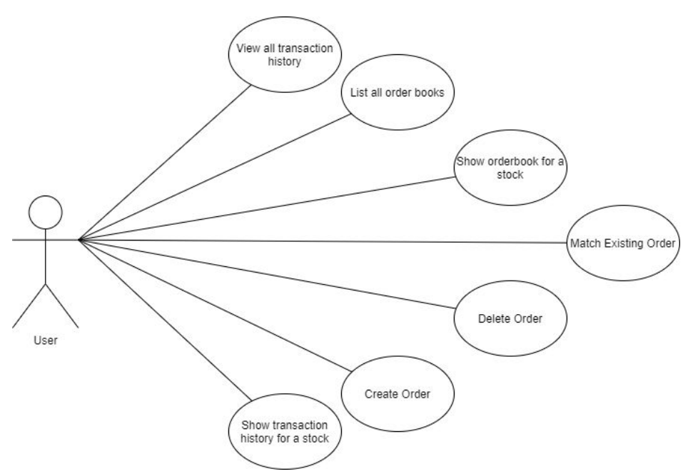

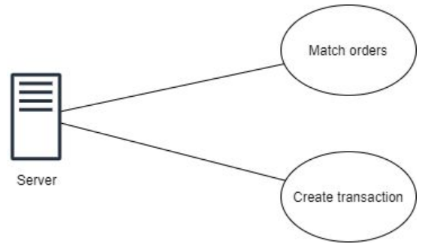

3.2. Use case realisations
3.2.1. User specific use cases
3.2.1.1. View transaction history for symbol from navigation bar
Use case name View transaction history for symbol from navigation bar
Scenario User wants to view all transaction history for an orderbook for a specific symbol using the navigation bar.
Triggering Event Clicking symbol name from “View Trade History” dropdown menu in navigation bar.
Brief Description On click, a drop down menu will appear listing all symbols currently tracked by the application. From this list, a user needs to choose a symbol to be redirected to an orderbook for said symbol.
Actors User
Related use cases View transaction history for symbol from home page
Preconditions None
Post conditions None
Flow of events User loads any webpage for the program. User chooses “View History” from the navigation bar. User chooses a symbol from the drop down list. Application requests all transactions from the connected database. Application adds transactions to the webpage via model. Application redirects users to the webpage. Webpage populates with the given model.
Exception conditions If the symbol cannot be found, the user will be redirected to an error page asking them if they would like to create an orderbook for said symbol.

3.2.1.2. View transaction history for symbol from home page
Use case name View transaction history for symbol from home page
Scenario User wants to view all transaction history for an orderbook for a specific symbol from the home page
Triggering Event Clicking “View Trade History” button in symbol activity form
Brief Description On click, the user will be redirected to the trade history for a selected symbol’s orderbook.
Actors User
Related use cases View transaction history for symbol from navigation bar
Preconditions None
Post conditions None
Flow of events User loads the home page User chooses a symbol from the drop down menu in “Symbol Activity”. User chooses “View Trade History” directly below the symbol drop down menu. Application requests all transactions from the connected database. Application adds transactions to the webpage via model. Application redirects users to the webpage. Webpage populates with the given model.
Exception conditions If the symbol cannot be found, the user will be redirected to an error page asking them if they would like to create an orderbook for said symbol.

3.2.1.3. Show orderbook for a stock symbol from navigation bar
Use case name Show orderbook for a stock symbol from navigation bar
Scenario User wants the orderbook for a specific stock using the navigation bar
Triggering Event User chooses a symbol from the “View an Orderbook” drop down menu in the navigation bar.
Brief Description Clicking on the button “View Orderbook” will open a drop down list containing all symbols currently tracked in the application.
Actors User
Related use cases Show orderbook for a stock symbol from home page
Preconditions None
Post conditions None
Flow of events User clicks “View an Orderbook” from the navigation bar. User chooses a symbol from the opened drop down menu. Application gets all orders for said symbol and adds them to the model. Application redirects user to a webpage to display orders. Webpage populates with all orders from the model.
Exception conditions None.

3.2.1.4. Show orderbook for a stock symbol from home page
Use case name Show orderbook for a stock symbol from navigation bar
Scenario User wants the orderbook for a specific stock using the navigation bar
Triggering Event User clicks “View Orderbook” in symbol activity form
Brief Description On click, the user will be redirected to the orderbook for the selected symbol.
Actors User Related use cases Show orderbook for a stock symbol from navigation bar
Preconditions None
Post conditions None
Flow of events User chooses the symbol from the drop down menu located in the symbol activity form. User chooses the “View Orderbook” button directly below the chosen symbol. Application gets all orders for said symbol and adds them to the model. Application redirects user to a webpage to display orders. Webpage populates with all orders from the model.
Exception conditions None.

3.2.1.5. Match existing order
Use case name Match existing order
Scenario User matches top buy/sell order
Triggering Event User clicks “Match” button next to an order
Brief Description On click, an order will be generated that will match the chosen order (price, amount, etc.) with the exception of the order type (this will be the opposite). Once created, a transaction is conducted using the two orders, fulfilling both and creating/updating the relevant entries in the database for storage.
Actors User Related use cases Make transaction
Preconditions At least one order must exist and the given order must be at the top of the list for their type (highest buy price or lowest sell price).
Post conditions Orders should be fulfilled and a transaction connecting the two should be created. All three will be updated/saved to the database. Flow of events User chooses the top order they want to fulfill. An opposite order is generated based on the order chosen. Orders are used to create a transaction, which is stored in the database along with the updated(fulfilled) orders. 8 Exception conditions If no orders exist, this operation is not available to the user.

3.2.1.6. Delete order
Use case name Delete order
Scenario User chooses to delete an order from an orderbook for a given symbol
Triggering Event User chooses delete for an order
Brief Description On click, the selected order will either be deleted completely from the database or will be considered inactive (size will be set to zero) so it will not be displayed. This is done only if the selected order has been previously used for a transaction(s).
Actors User
Related use cases None
Preconditions A order must exist
Post conditions An order considered inactive by the application (size will be 0) or the order will be deleted.
Flow of events User clicks “Delete” for an order. Order is checked against the database to see if any transactions exist that reference the said order. If such a transaction exists, the order’s size is set to zero to be considered inactive. Otherwise it will be deleted completely from the database.
Exception conditions None

3.2.2. Automated use cases

3.2.2.1. Match orders
Use case name Match Orders
Scenario Two orders are compared to see if a transaction is possible.
Triggering Event Triggers via a timer within the application.
Brief Description For two given orders, the application will compare the elements of each order. This includes the price, the stock symbol and the amount. If a transaction can be created using the two orders, it will be created.
Actors Application
Related use cases Create transaction
Preconditions Two orders capable of a transaction
Post conditions Updated orders and a new transaction.
Flow of events Two orders are collected for comparison. Comparisons are done on price, amount, and symbol. Assuming symbol matches, the amount can be at least partially fulfilled for one and completely for the other, the orders are sent to create a transaction. Exception conditions Orders are not compatible, in which case no transaction is made.

3.2.2.2. Create transaction
Use case name Create transaction
Scenario Two orders are used to create a transaction, updating the orders to show the proper values as well.
Triggering Event Called by “Match Orders” and “Match Existing Order”. See related for more information.
Brief Description Two orders are used to create a new transaction object. This transaction will contain the price, amount of stocks traded, symbol of the stocks, and date of creation. This will be recorded and the orders used will have their values in storage updated to reflect the change in amount.
Actors Application
Related use cases Match Orders, Match Existing Order
Preconditions Two orders that are compatible.
Post conditions Two updated orders and a newly created transaction.
Flow of events Two orders are sent in. The necessary data for the transaction is pulled from the orders. The symbol will match the two orders. The price will be set to equal the buy order price. The amount will be set to the lowest amount value of either order. Orders will be updated to reflect their new amount values. Transaction will be recorded.
Exception conditions None.

4. Activity Diagrams
4.1. Automatic Order Matching/Runtime processes
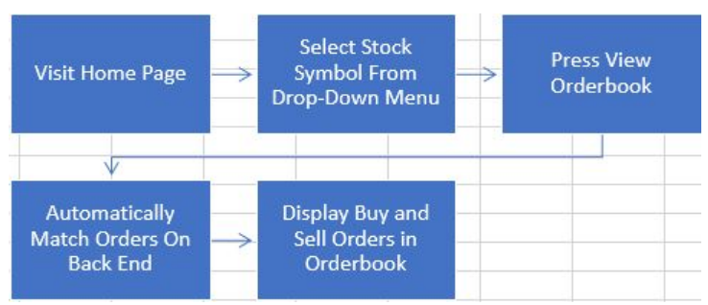
4.2. Adding an Order
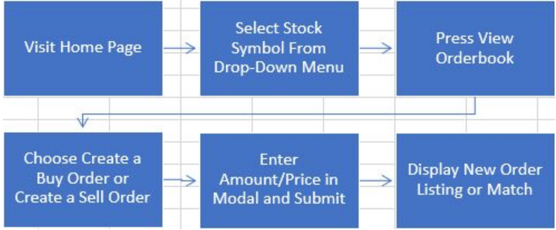
4.3 Create New Orderbook
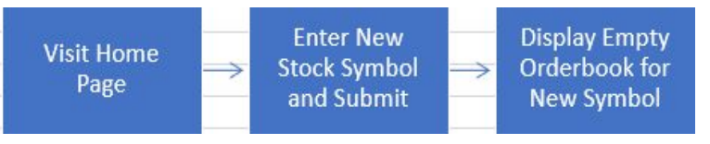
4.4 Deleting an Order
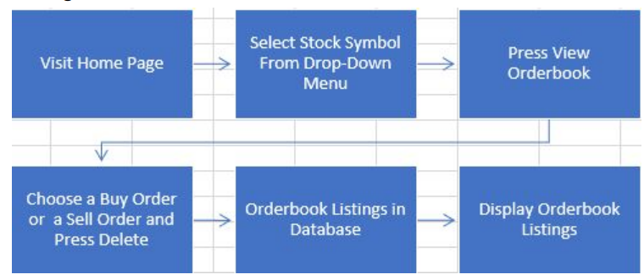
4.5 Manual Order Matching
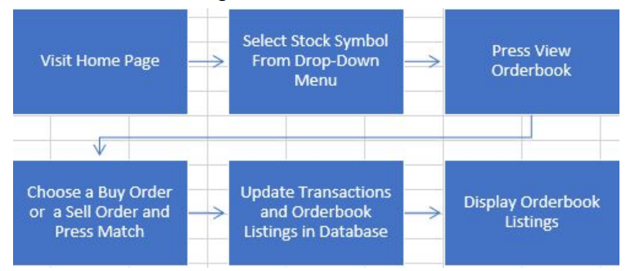
5. Implementation View
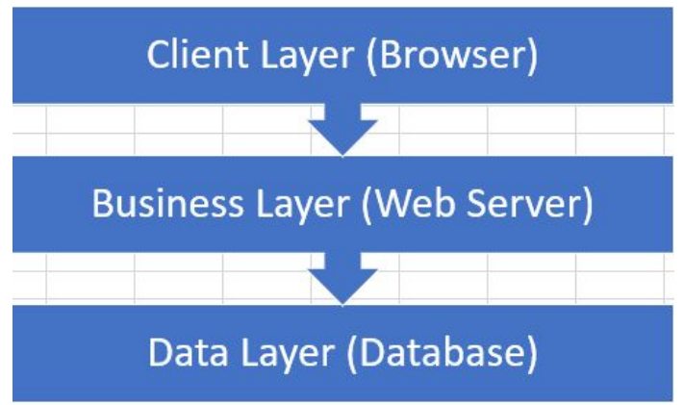

The application was created in the style of MVC. The reasoning of this was to control what each layer could access to avoid unnecessary/unexpected changes to the data and to other aspects of the application. View layer (client layer) is the user interface (web pages). The actions the user takes in these web pages is handled by controller classes. These controller classes in turn call functions from the service model classes to handle data and business logic. Doing this has the added benefit of reducing complexity by reducing the sizes of each function. The business layer (service layer) contains all business logic and connects the view layer (controller) with the data layer. The data layer in turn connects the business layer with the connected database and is directly responsible for the saving and retrieving of data from a database.
6. Data View
6.1. ER diagram

6.2. MySQL implementation
The database was designed in MySQL.
The main tables are:
1. Order
2. Transaction
JPA framework is used to automate the relations between the two tables. Classes were also created for each table in the database, making it possible for the application to work with the database’s data.
Wireframes
1. Symbol Not Found
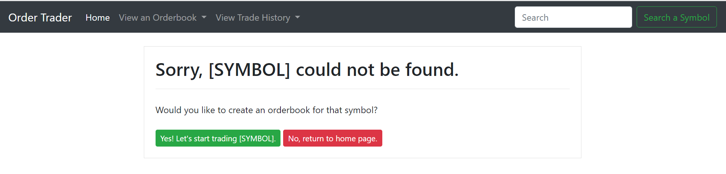
2. History
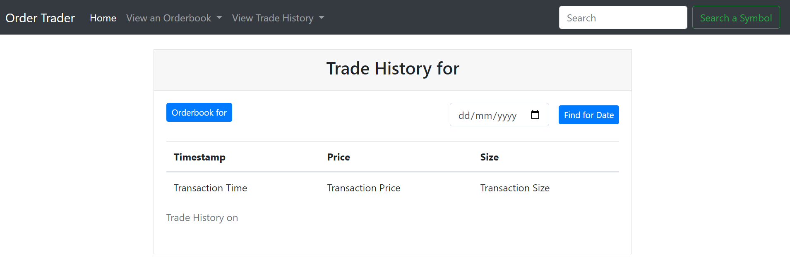

3. Edit Order
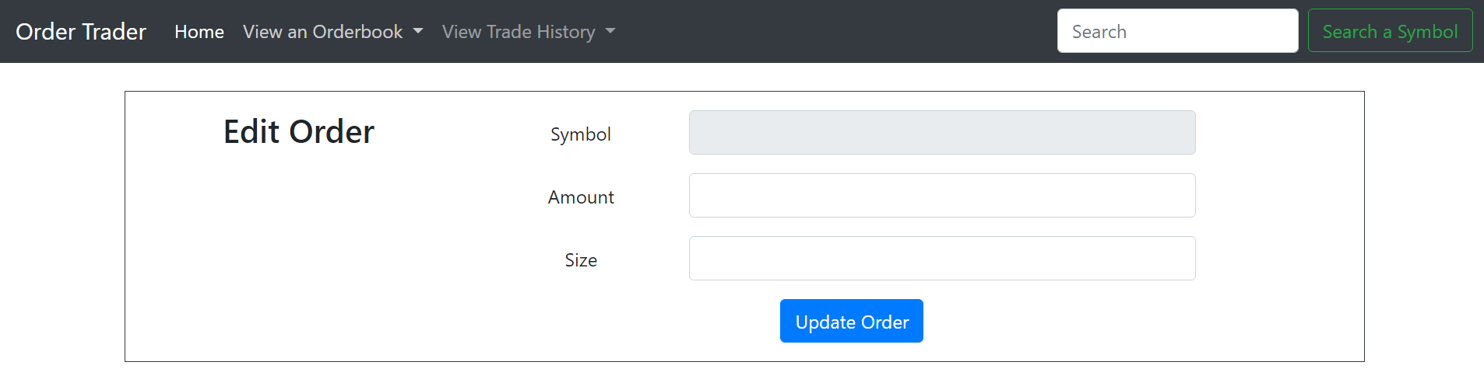
4. Index
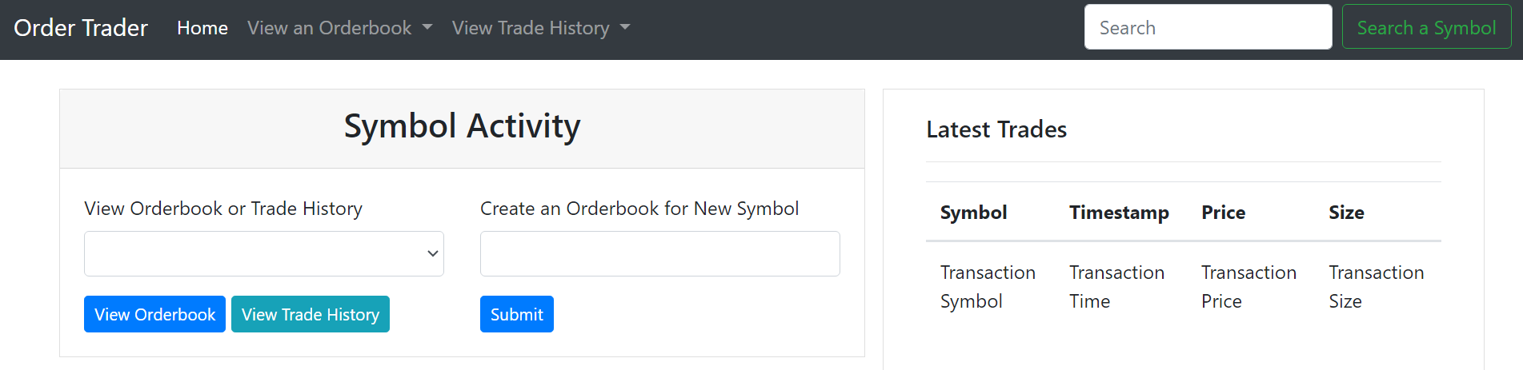
5. Orderbook
